**LAB NO 4**

**SUBMITTED BY:**

**RABEEA FATIMA  
REGISTRATION NO: 2023-BSE-049**

**SECTION: B  
SUBJECT: CLOUD COMPUTING**

**TASK 01:**

**Verify VM Resources in VMware.**

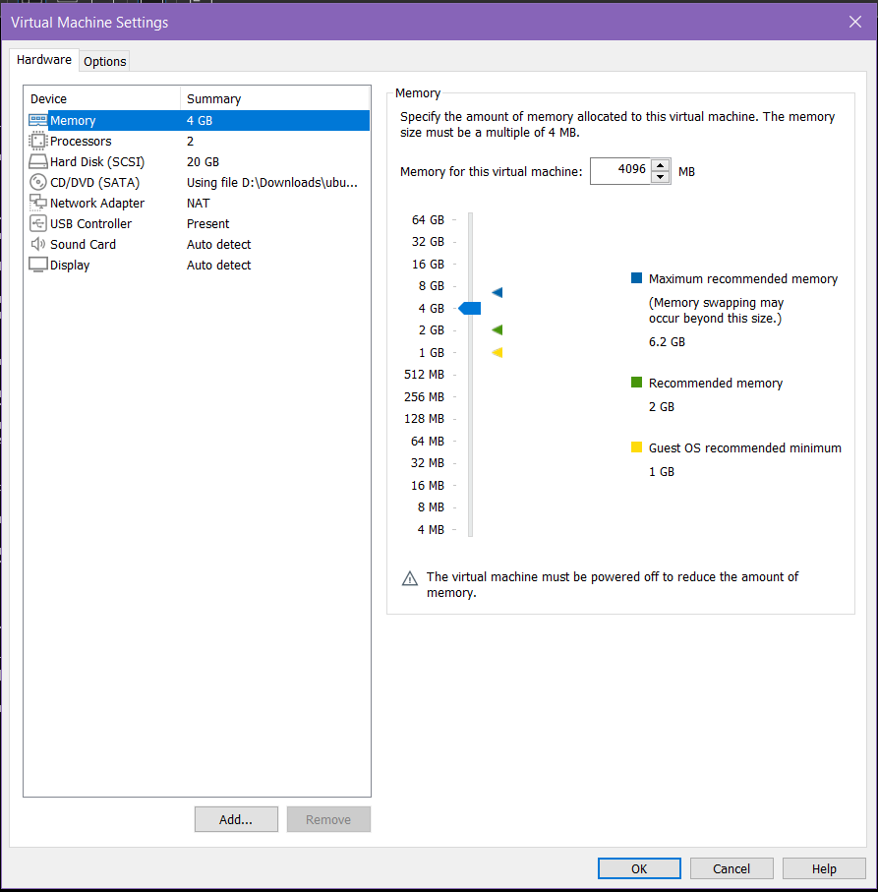

**TASK 02:**

**Start VM and Log In (Using SSH)**

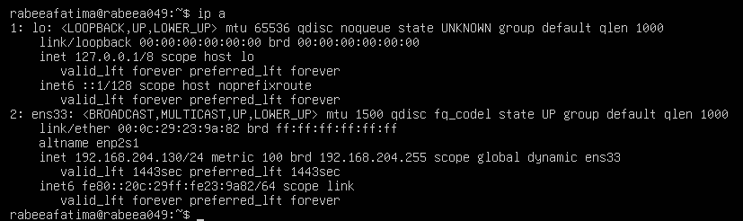

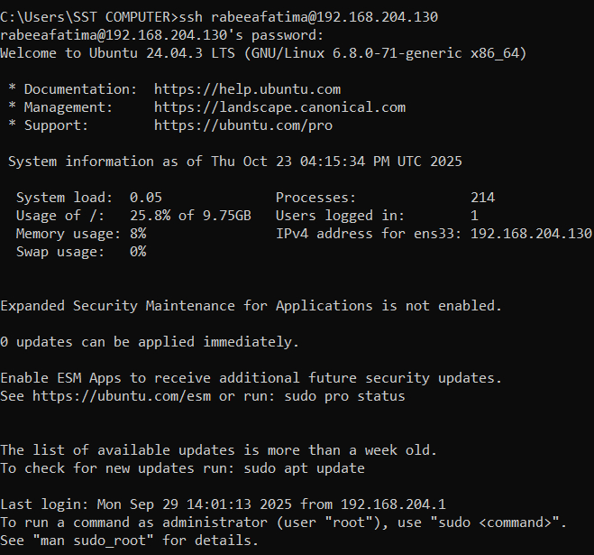

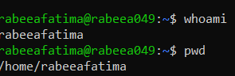

**TASK 03:**

**Explore the Filesystem and Hidden Files**

Step 1: Type each of these commands **one by one** and take screenshots after each.

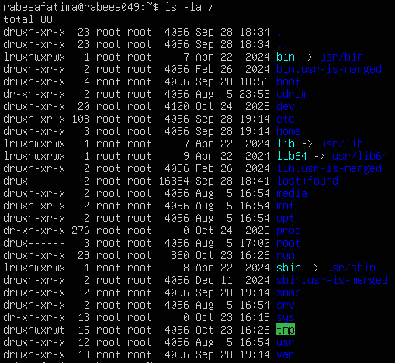





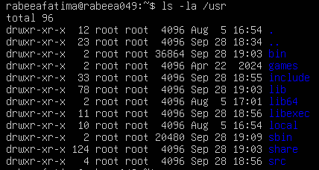

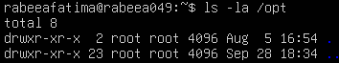



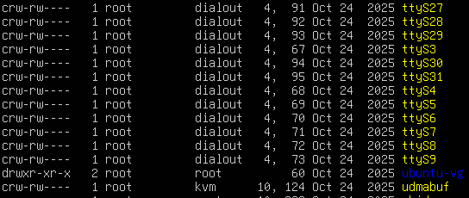



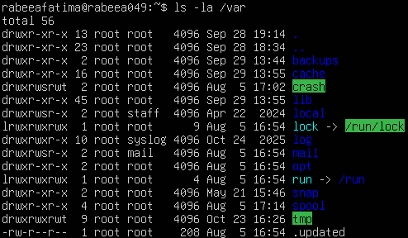

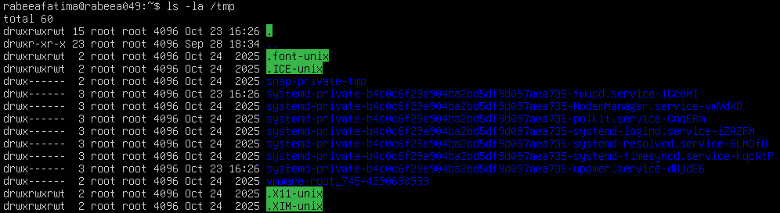

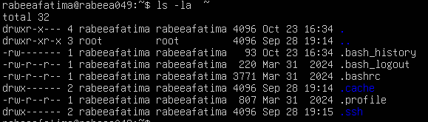

Step 2: **Now write a short paragraph** explaining: What is /bin, /usr/bin & /usr/local/bin

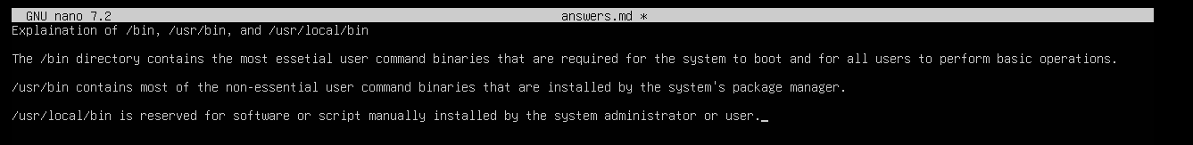

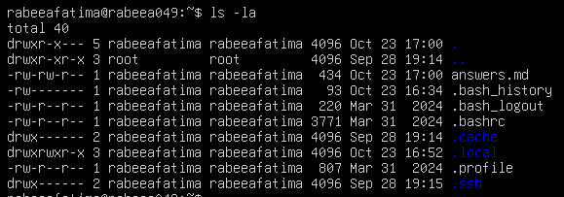

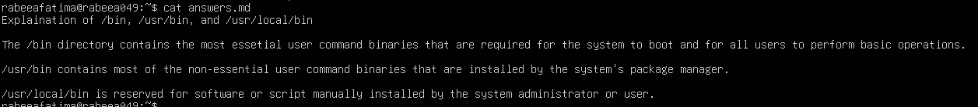

**TASK 04:**

**Essential CLI Tasks (Navigation & Files)**

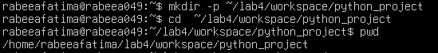

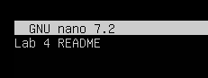



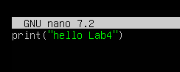

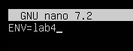

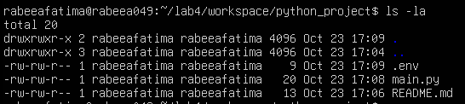



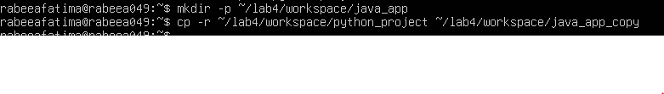

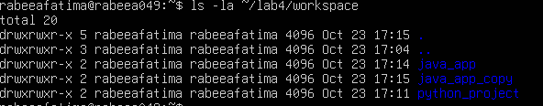

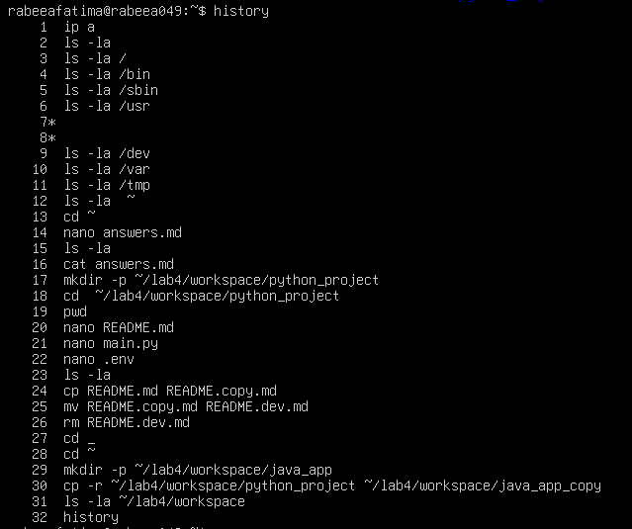



**TASK 05:**

**System Info & Processes**





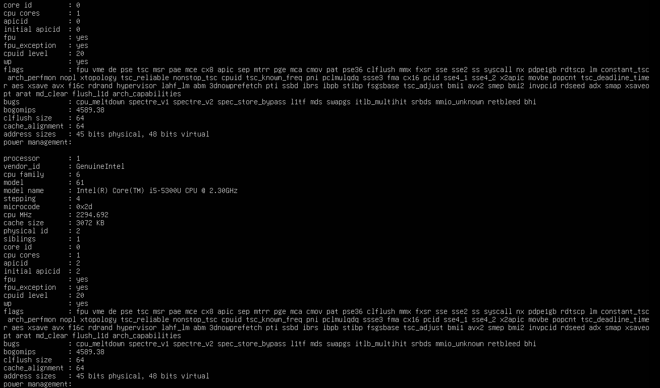

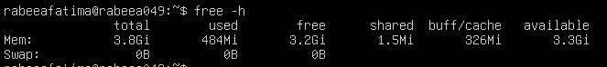

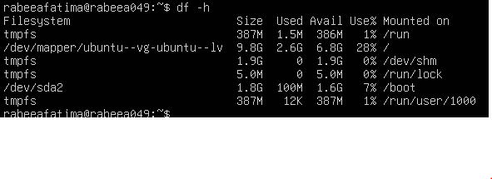

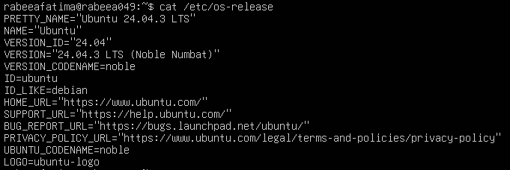



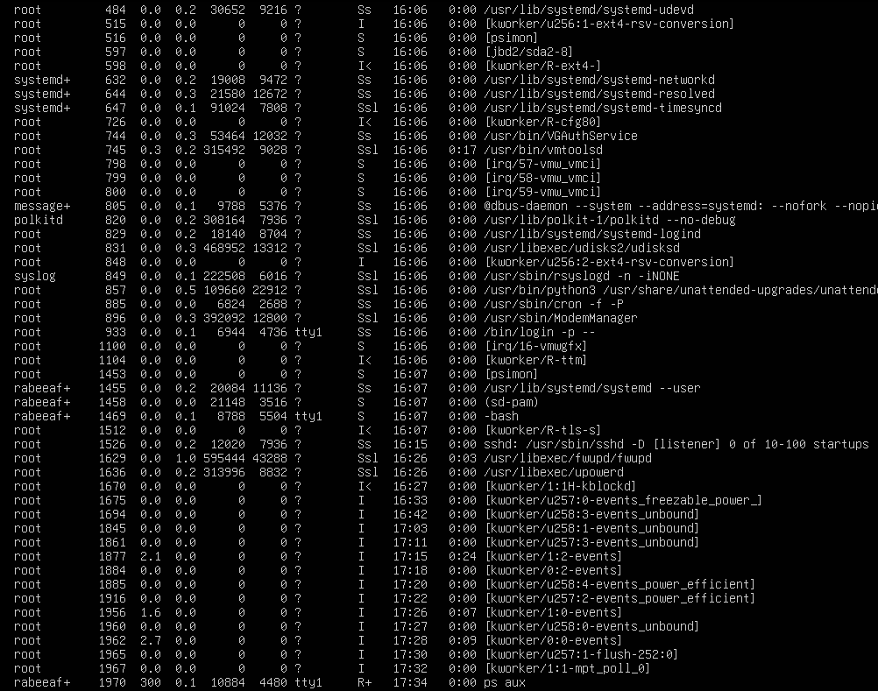

**TASK 06:**

**Create and Verify User**

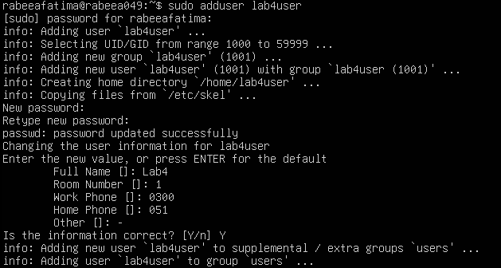

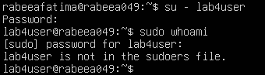

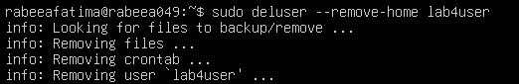

**BONUS TASK 07:**

**Small Demo Script**

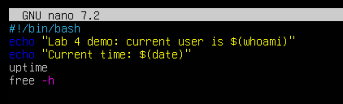

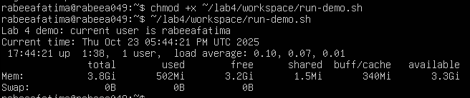

**EXAM EVALUATION QUESTIONS**

**QUESTION 01:**









**QUESTION 02:**























**QUESTION 03:**







